Project 03 Documentation

Blake Merry
Southern New Hampshire University
CS-210 Programming Language
Dr. Barbara Hecker
April 18, 2026

Program Summary
This program reads a list of grocery items from an input file and tracks how often each item appears. The program stores this data using a map structure, which allows the program to efficiently count and organize each item. Once the data is processed, the program presents a menu that allows the user to search for a specific item, view all item frequencies, or display a histogram of the data.
In addition to displaying results, the program also generates a backup file (frequency.dat) that contains all the calculated frequency data. This file is created automatically when the program starts.

Design and Approach
I structured this program using a class-based design to keep “responsibilities” clearly separated. The GroceryTracker class handles all data-related operations, including reading input, storing frequencies, and producing output. The main() function is responsible for managing user interaction.
To store the grocery data, I used a map<string, int>. This was a good fit for the problem because it allows each item to be associated with a frequency count while also keeping the data sorted. This made it easier to implement both searching and formatted output without becoming too complex.
Each menu option maps directly to a specific function within the class. This approach made the program easier to organize and reduced the likelihood of duplicating logic across multiple parts of the code.

Functionality
When the program starts, it reads data from the input file and builds a frequency map of all grocery items. After processing the data, it writes the results to a backup file named frequency.dat.
The program then displays a menu that includes four options. The first option allows the user to search for a specific item and returns the number of times it appears in the data. The second option displays all grocery items along with their frequencies. The third option presents the same data in a histogram format using asterisks to represent frequency. The fourth option exits the program.
Input validation is included to handle invalid menu selections. If the user enters a non-numeric value, the program clears the input and prompts the user again. Basic exception handling is also used when working with files to ensure that errors are handled gracefully.

Menu Display
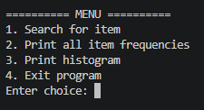
Shows the menu presented to the user when the program starts.

Search for Item (Option 1)
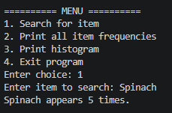
Example demonstrating searching for an item and displaying its frequency.

Frequency List (Option 2)
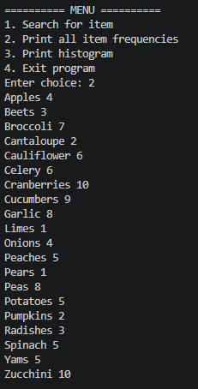
This output shows all grocery items along with their calculated frequencies.

Histogram (Option 3)
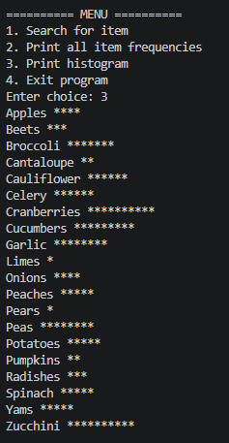
Histogram representation of the data using asterisks.

Exit Program (Option 4)
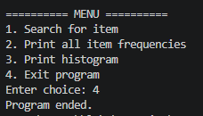
Demonstration of the program exiting cleanly when the user selects option 4.

Challenges and Solutions
One of the main challenges in this project was handling input safely. If invalid input is provided, like entering a letter instead of a number, it can cause the input stream to fail and disrupt the program. I addressed this similarly to in Project 02 by checking for input failure, clearing the state, and discarding invalid input before continuing.
Another challenge was organizing the program in a way that was clear and maintainable as more functionality was added. Separating the logic into a dedicated class helped keep the program structured and made it easier to manage each feature independently.

What I Learned
This project reinforced the importance of organizing code in a way that separates responsibilities between program components. Using a class to handle data processing made the program easier to test and extend.
I also gained more experience working with maps and saw how useful they can be for counting and organizing data efficiently. Additionally, this project helped strengthen my understanding of input validation and exception handling, both of which are important techniques for building more reliable programs.
Overall, this project was a great exercise in writing cleaner and more structured code.

